Nonprofit Advocacy Tools Assessment
[Organization Name], [Month, Year]

HOW TO USE THIS TEMPLATE

To use this document in Google Docs, sign in to your Google Account, go to File > Make a Copy. Rename your copy and get started editing.

To edit this document in Microsoft Word, go to File > Download and select Microsoft Word.

This template is intended as a starting point in understanding your organization’s technology needs to build or expand an advocacy program. Customize the sections to meet your needs, and refer back to our Nonprofit Advocacy Tools and Technology Guide for more tips.

Table of Contents

Plan your Advocacy Journey 2
What tools and technology do you already have in place? 4
Identify gaps and start researching new tools or integrations 5

Plan your Advocacy Journey
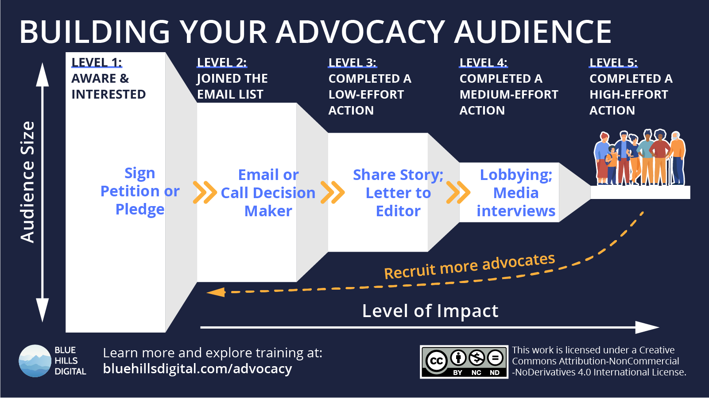
Refer back to the framework for Building an Advocacy Audience. Fill out the table below with details of the audience members and advocacy actions at each stage for your organization.
Answering these three questions will help you define goals for your advocacy program. The answers don’t need to be exact — the questions are intended to start a conversation about your current advocate journey.
- What actions indicate someone has reached this level at your org?
- How many people in your audience have reached this level currently?
- Where does this data live
If you don’t have the tools for one of these steps yet, or haven’t set the tools up yet, enter the information anyway and highlight the cell to return to later.

Level | What actions indicate someone has reached this level at your org? | How many people in your audience have reached this level currently? | Where does this data live?
1: Aware and interested | - Following one of our social media channels  - Visiting our issue or blog URLs on the website | We have ~ 20k followers across all social channels.  We average 15k active users on the website each month | - Social channels
Joined the email list | - Sign up for email alerts  - Signed the petition for XYZ
Completed a low-effort action
Completed a medium-effort action | - Submitting a story for inclusion in a story library | Haven’t built the story library yet
Completed a high-effort action

What tools and technology do you already have in place?
In the table below, enter details about any existing tools, technology, or software you already have that serves any of the functions listed.
- In the Tool Name column, consider including a link to the tool vendor website.
- In the Details column, consider adding notes about the annual cost of each tool and the staff member or team that has primary responsibility for the tool.
Function | Tool Name | Details (e.g. annual cost, staff lead)
Website | WordPress website | MarComms
Social media channels | Instagram, TikTok
Bulk email marketing | Mailchimp
SMS / Text Messaging
Online Form Builder
Advocacy Action Tools (petitions, call/email)
Donation forms
Donor CRM
Workflow automation
Web analytics

Identify gaps and start researching new tools or integrations
The final step in this assessment is to map out your ideal advocacy user journey — we recommend using a whiteboard or other visual tool to start this process.
For each step or action that audience members take, include notes about (A) where you will use existing tools, OR (B) highlight steps where you don’t yet have a tool that provides the functionality you need.
These highlighted gaps will give you the starting point for researching what new tools you need to invest in.

Need more support?

Check out the tips in our Nonprofit Advocacy Tools and Technology Guide. The guide also includes a link you can use to schedule a free consultation or training for your organization. We would be happy to help.

